**EASO and Frontex sign updated Cooperation Plan**

2019-07-18

Today the European Asylum Support Office (EASO) and the European Border and Coast Guard Agency (Frontex), strengthened their cooperation in their respective work on asylum, border control and migration management.  
  
The updated Cooperation Plan was signed by the Executive Director of EASO, Nina Gregori, and the Executive Director of Frontex, Fabrice Leggeri, in Helsinki at the informal Justice and Home Affairs Council meeting. Dimitris Avramopoulos, the European Commissioner for Migration, Home Affairs and Citizenship, and Maria Ohisalo, the Finnish Minister of the Interior who represents the Presidency of Finland of the Council of the EU attended the signing ceremony.   
  
“The European Asylum Support Office and the European Border and Coast Guard Agency are Europe’s key agencies in supporting Member States to better manage asylum, migration and border challenges. I therefore very much welcome that they will strengthen their cooperation even more for the future,” said Commissioner Avramopoulos.

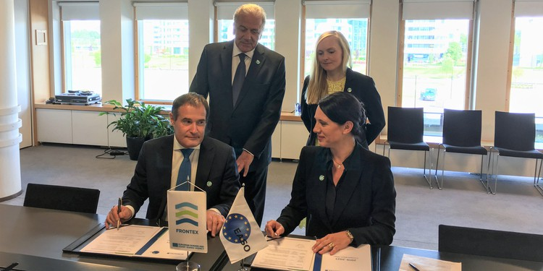

Fabrice Leggeri said: “Today we’re strengthening the collaboration between our agencies, a cornerstone of the European migration policy. Frontex is looking forward to contributing its expanding field presence thanks to the development of the future Standing Corps and its unique expertise in providing the situational picture at the borders to pinpoint emerging challenges and trends.”  
  
Nina Gregori stated: “EASO is delighted to renew and update this Plan with our sister Agency, Frontex. Our two Agencies work hand-in-hand to support Member States in the field of border management and asylum through training, analytical work, data gathering and concrete operational support on the ground. That is why it is important that our cooperation at all levels has continued to strengthen over the past years and that today we are reiterating this cooperation by providing a roadmap for our joint work in the future.”  
  
The Cooperation Plan covers the 2019-2021 period and follows a previous Cooperation Plan for the years 2017-2018. The document will govern joint work in the areas of operational cooperation, information and analysis, capacity building and horizontal cooperation. The two agencies will work together on projects such as the set-up and implementation of the Migration Management Support Teams (MMST), as well as delivering a Common Situational Picture on irregular migration and persons in need of international protection.  
  
Both agencies have been assisting national authorities in hotspots and work together to provide a full situational picture about migratory flows into the European Union and persons in need of international protection in order to help the authorities be better prepared to manage these flows.   
  
Any further information may be obtained by contacting: press@easo.europa.eu or press@frontex.europa.eu